Computer Graphics

Project Name: Rocket with Airstrike Game

Objectives
- To develop an easy-to-use GUI-based DNA/RNA analysis platform.
- To automate tasks like GC content, transcription, translation, and codon usage analysis.
- To integrate multiple sequence alignment and phylogenetic tree construction.
- To support researchers in performing molecular biology analyses efficiently.

Requirement Collection:
- Main Menu
- Difficulty levels
- Score display
- Identifying the game with some features like moving rocket , collision detection , planes , bombs , scoring difficulty
- Score display using file read to show the display
Requirement Analysis:
- User: Me or My friends
- User to start this game using option choose and its user friendly
- Choose difficulty level and play the game like conditions
Requirement Validation:
- Checking all the game rules and other things are implemented correctly
- Ensuring the game works through debugging and testing
Module Identification:
- Divide the game with different modules like Plane , Rocket , BigPlane , Boom , BigPlane Bomb .
- Separating concerns such as rendering , event handling and logic

Scenario diagram:
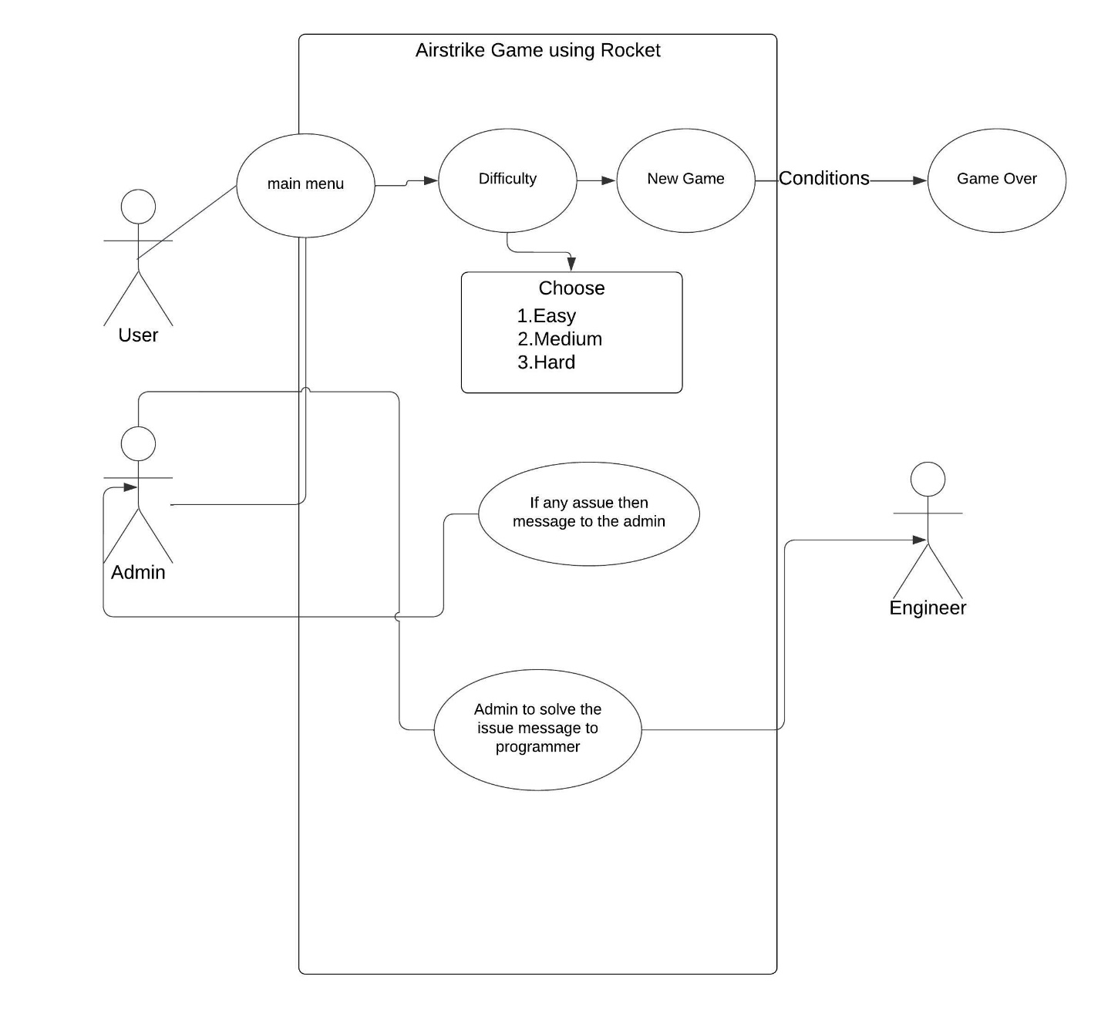

UI Interface Design:
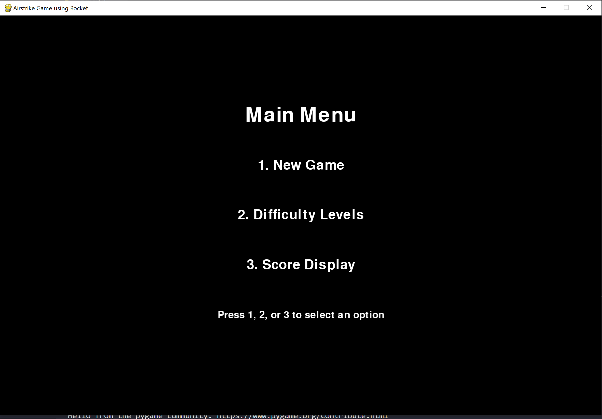

Class Diagram:
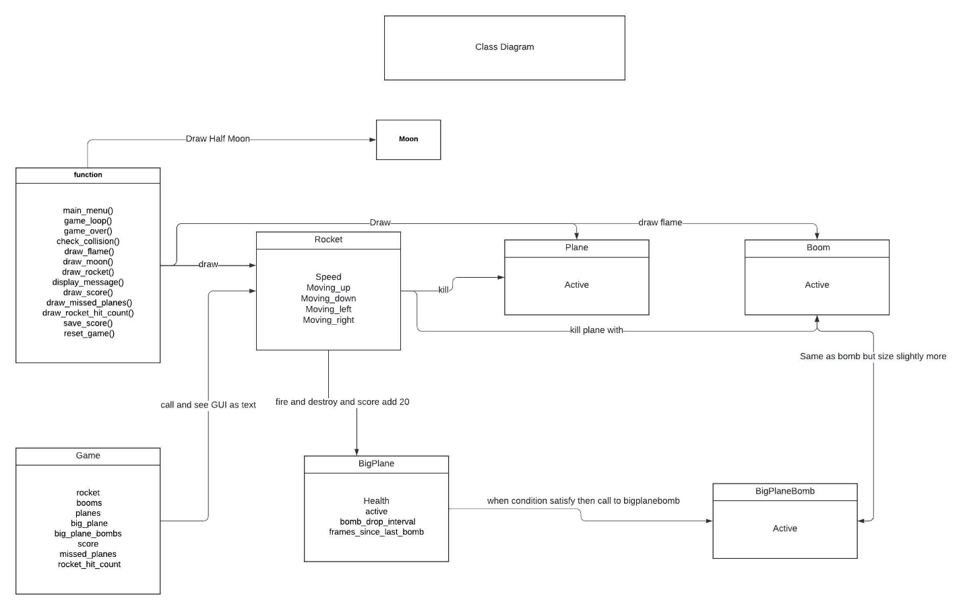

Software Testing:
- Testing different features of the game like collision detection, movement, score updating, and game over conditions.
- Manual testing through gameplay and ensuring all features work correctly.

Estimation for software Project:
- I use the bottom up estimation technique because of detailed planning , more accuracy , easier justify to transparency , potential granular level at risk management.

Sequence Diagram:
Player -> Rocket: pressSpacebar()
Rocket -> Game: createBoom()
Game -> Boom: Boom()
Loop (for each frame)
Game -> Boom: move()
Boom -> Plane: checkCollision()
alt if collision
Boom -> Plane: deactivate()
Boom -> Game: incrementScore()
end
end

Computer Graphics term used:
- Rendering: Drawing shapes and rendering text
- Transformations: Moving Object and Scaling
- Collision Detection: for Objects
- Animation: moving objects and create flame effects
- Event Handling for user input
- Sound integration

